Silver Hill Hospital
Patient Financial Assistance Fund Policy
OVERVIEW
At Silver Hill Hospital, we understand the financial challenges that can act as a barrier to accessing quality mental health and substance use services. To support our patients and their families, we offer a comprehensive Patient Financial Assistance Fund Policy.
WHO QUALIFIES
This policy specifically applies to the following patients:
- Who are uninsured, or
- Have exhausted their insurance benefits, and
- Meet the 2026 Federal Poverty Guidelines (FPG).

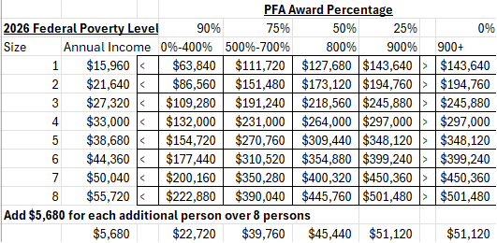

EXCLUSIONS: This policy excludes those with insurance coverage who choose not to utilize it, as well as costs related to coinsurance, copayments, and deductibles.
FINANCIAL ASSISTANCE AWARD AMOUNTS
Financial assistance awards range from 25%-90% of the current Medicare payment of $1,395 per day, based on the 2026 Federal Poverty Level Guidelines.

APPLICATION PROCESS

- Applications for patient financial assistance should be submitted to Patient Accounts prior to admission to determine eligibility via email at SHHFinancialAssistance@silverhillhospital.org.
- Applications must include the following elements:
  - Inpatient Program Financial Assistance Application Form
  - Driver’s License and Insurance Card
  - Copies of last two prior year’s W2/W9/1099 forms
  - Most recent Pay Statements
  - Most recent Federal Tax Returns
  - Documentation of other income and assets
  - If the patient is declared as dependent on another’s tax return, the above financial documentation requirements will need to be submitted from the financial guarantor.
- The patient/guarantor is required to sign a document attesting that the information provided is true and accurate. The attestation form and supporting documentation are submitted to the Manager /Director of Revenue Cycle.
- Proof of the origin of payment(s) is required and will need to be submitted for verification.
- Final review and approval of the financial assistance request is performed by the Chief Financial Officer or designee.
ELIGIBILITY

- The patient is a US resident and has continuously maintained residence within the US and its territories for a period of at least 12 consecutive months immediately preceding admission.
- The patient has not previously been a financial assistance recipient.
- Financial assistance is subject to the availability of funds.
- Silver Hill Hospital reserves the right to deny any application at its sole discretion. This policy excludes patients who have insurance but do not wish to use it. Coinsurance, co-payments, and deductibles are also excluded from this policy.
- Financial Assistance must be applied for and approved prior to admission to the inpatient unit.

PURPOSE

This policy establishes the definitive framework for providing financial assistance and ensures compliance with Section 501(r)(4) of the Internal Revenue Code.

