

SILVER HILL RESIDENTIAL

PATIENT FINANCIAL ASSISTANCE APPLICATION
Patient: | Guarantor:
Medical Record #: | Medical Record #:
Date of Birth: | Social Security # (if issued):
Social Security # (if issued): | Home Phone:
Home Phone: | Work Phone:
Work Phone: | Relation to Patient:
Address: | Address:
# of dependents in the household: | # of dependents in the household:
Are you a dependent? Circle Yes or No | Is the patient a dependent? Circle Yes or No
Insurance Name: | Insurance Name:
Policy #: | Policy #:
Occupation & Employer: | Occupation & Employer:

Please provide the following financial information:
MONTHLY INCOME
 | Salary/Wages | Self-Employment Income, Child Care Income, Alimony, Child  Support | Unemployment Income, Social Security, Pension Benefits,  Worker’s Compensation | Interest, Dividends, and/or Annuity Payments
Patient
Spouse
Guarantor

ASSETS
Bank accounts:
Checking
Savings
Investment accounts:
Retirement accounts:
 | Year acquired | Purchase Price | Market Value | Mortgage/loan
Primary residence
Vacation property
Cars
Boats
Planes
Other Real Estate

“I attest that I do not have financial means to cover the full costs of the program and request the facility to make a determination of eligibility for financial assistance. I understand that this information is confidential and subject to verification by the facility. I also understand that if the information I provide is false, I may be denied financial assistance at the sole discretion of Silver Hill Residential and be liable for payment for the hospital services provided. I hereby attest that the information in this application is complete and correct to the best of my knowledge and that I understand the process and my responsibilities.”

Guarantor’s Signature: _ Date: :

Facility Representative’s Signature: Date:

Please attach copies of the following documents, if applicable:
Income Source: | Proof of Income:
Salary/Wages | Most recent Federal Income Tax return (signed) and your most two recent pay  stubs
Self-Employment Income, Child Care Income, Alimony, Child Support | Most recent Federal Income Tax return (signed)
Unemployment Income, Social Security, Pension Benefits, Worker’s  Compensation | Most recent Federal Income Tax return (signed) or other proof
Interest, Dividends, and/or Annuity Payments | Most recent Federal Income Tax return (signed) or Statement from financial  institution stating the amount and frequency paid year to
If you have no income | A letter from the person who supports you or a letter signed by you explaining  your current financial situation.
Assets | Proof:
Bank Accounts | Most recent bank statement
Investment Accounts | Most recent Investment account Statement
Retirement Accounts | Most recent Retirement account statement
Primary residence | Deed and most recent mortgage statement
Vacation property | Deed and most recent mortgage statement
Cars | Purchase receipt and most recent loan statement
Boats | Purchase receipt and most recent loan statement
Planes | Purchase receipt and most recent loan statement
Other Real Estate | Deed and most recent mortgage statement

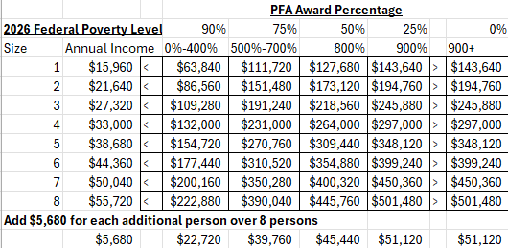
We are able to offer financial assistance to patients with need because of the generous gifts of Silver Hill donors. When your stay at Silver Hill is complete, and if you are satisfied with your treatment program, there is an opportunity for you to play a significant role in ensuring future financial assistance for other patients like yourself. By writing or recording short “impact statement” describing how your stay at Silver Hill has helped you, you will inspire donors to continue to provide these crucial funds to others in need. Many patients have a desire to “give back” when their stay is completed, and this is a simple and much appreciated way to do just that. Silver Hill staff is available to help you to write a statement should you need any assistance at all. Thank you for being an important part of the cycle of giving.

